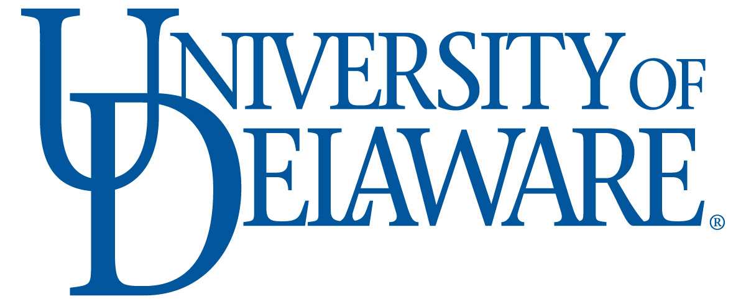 | Biotechnology PSM Internship  Student Interim Evaluation Form | 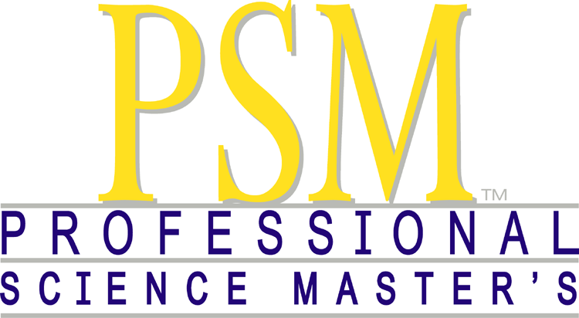

Student Name: |  | Date:
Company/Organization:
Supervisor Name: | Title:
Phone: | E-mail:
Are you involved in a project or work that you think is useful to the company/organization?
Yes: | No:
Are you working on the project and have the responsibilities you expected when you joined this company/organization?
Yes: | No:
Please use the space below to describe the project and/or your responsibilities.

Do you think you are meeting your learning objectives? Please comment:

Please describe your level of satisfaction with your work, responsibilities and supervisor

Comments & Feedback (please use this space to address any issue that need to be addressed):

Please return this form to: Melinda K. Duncan, Ph.D.
Professor and Graduate Program Director
Department of Biological Sciences
University of Delaware
327 Wolf Hall
Newark, DE 19716
OR email duncanm@udel.edu

